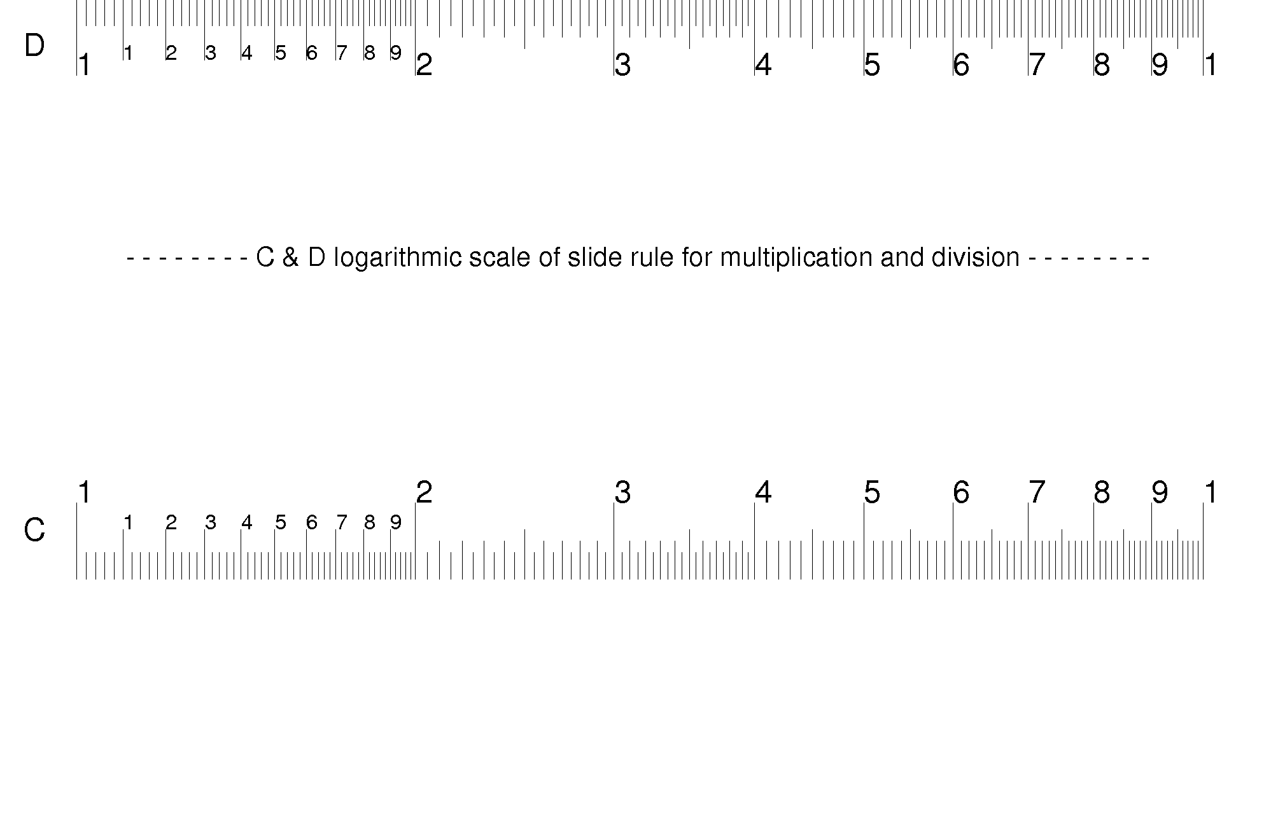
Business Card
Slide Rule
Wee-Meng LEE
Jun 2005

Most of the time we just need to do basic multiplication and division. My friends have often asked me why use a slide ruler when calculators are now ubiquitously found on mobile phones. I’ve often demonstrated that by the time they find the calculator menu on their mobile phones, I’ve already found the answer.

The diagram on the left makes 2 business card size slide rule, one for your friend and one for yourself. There are 2 ways to use it:

1. Simply align the C and D scales on the 2 cards.

2. The other way is to take one of the cards and fold along the words “ ---- C & D logarithmic … ----“.
Take the other card and slot it into the folded card such that the C and D scales are aligned.

D 1' ' ' ' ' ' ' ' 2 ' ' ' ' ' 3 ' ' ' '4 ' '5 ' '6 ' '7' '8'9
D 1' ' ' ' ' ' ' ' 2 ' ' ' ' ' 3 ' ' ' '4 ' '5 ' '6 ' '7' '8'9
C 1. . . . . .. . 2 . . . . . 3 . . . .4 . .5 . .6 . .7. .8.9
Examples:
2 x 4
Position left most 1 on C scale, over 2 on D scale.
Locate 4 on C scale and read the results on D scale (8).

2 x 9
Position right most 1 on C scale, over 2 on D scale.
Locate 9 on C scale & read the results on D scale (18).

4 / 2
Position 2 on C scale, over 4 on D scale.
Locate left most 1 on C scale and read the results on D scale (2).

18 / 2
Position 2 on C scale, over 18 on D scale.
Locate right most 1 on C scale and read the results on D scale (9).

Print this on the back of business cards for the ultimate slide rule geek’s business card!

Enjoy!
Kenneth at leewm dot com
To lock the two slides together, create the folds as shown.





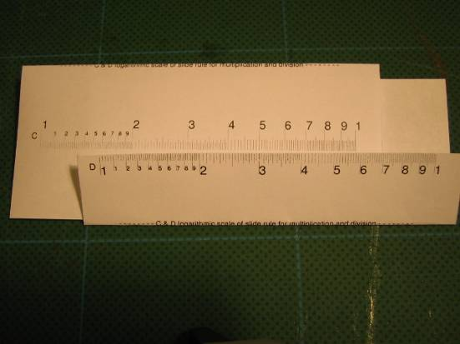

On the C slide, make mountain fold just below the numbers and the words.

On the D slide, make a mountain fold of about 3mm.

Fit together as shown and press flat.

The folds in the C and D slides would now interlock to prevent separation while at the same time allowing them to slide left/right.

